TOPIC | Judaism | Christianity | Islam
SYMBOL | 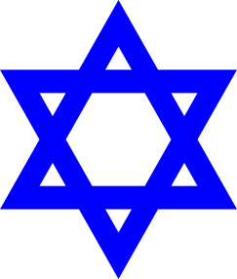 |  | 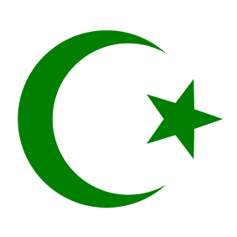
Followers are called |  |  | - Many Muslims in Europe.
# of gods Monotheistic or Polytheistic |  | - 1 god Monotheistic | - 1 god Monotheistic
TEACHINGS |  |  | FIVE PILLARS OF ISLAM  - Declaration of faith  - Pray 5 times a day  - Giving charity  - Fasting during Ramadan  - Pilgrimage (journey) to Mecca
TOPIC | JUDAISM | CHRISTIANITY | ISLAM
Beliefs

Day of worship |  | - Sunday | - EVERY DAY in prayers 5 times  - Worships in Mosques on Fridays.
Holy days(holidays) |  | - Christmas-Birth of Jesus  - Easter-Death and resurrection of Jesus | - Ramadan
House of worship |  | - Church
Leader/Teacher |  | - Pastor  - Preacher  - Priest | - Mudaris-One giving the lessons  - Various other names
Holy Text(book) |  | - Bible

