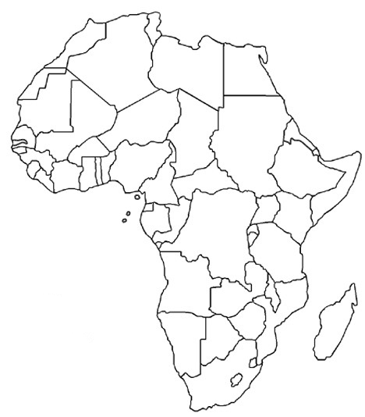
African Geography Study Guide: Maps
Directions: Find and label the countries and the physical features.
Be sure you are looking at the correct map!

Name: __________________________
Date: __________ Period: __________
Physical Features (Use Map Below)
Niger River
Nile River
Congo River
Lake Tanganyika
Lake Victoria
Atlas Mountains
Kalahari Desert
Lesson 1: Antebellum Georgia

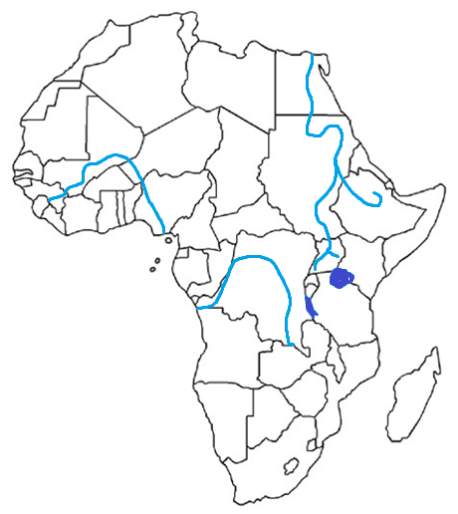

Political (Use Map above)
Democratic Republic of the Congo (Zaire)
Egypt
Kenya
Nigeria
South Africa
Sudan
South Sudan

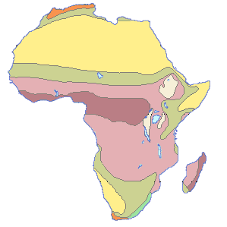
African Geography Study Guide: Maps
Directions: Find and label the climate zones below.

Read the passage and fill in the blank.

The Sahara Desert runs across the entire width of northern Africa. This is the largest desert in the world. It is covered with sand dunes, rolling rocky hills, and wide stretches of gravel that go on for miles and miles. Few people live in the Sahara; however, traders who travel by everything from camel caravan to jeeps and tricks cross its barren miles regularly.

The ____________ desert is the largest desert in the world.

In the middle of the continent, close to the equator, is the savanna region of Africa. It is a vast area of grassland and more tropical habitats. In this part of the continent, one finds many of the animals associated with Africa. The grasslands support lions, elephants, and many other species of animals. Farming is good here when the rains come. However, lack of rainfall can cause difficulties for farmers.

The “Savanna” is a vast area of ____________.

Climate Regions (Use Map Above)
Sahara
Sahel
Savanna
Tropical Rainforest

The Sahel is an area of Africa south of the Sahara Desert. It is an example of how poor farming practices and the destruction of trees and shrubs can lead to and expanding desert. Most historians believe that the Sahel was once rich farmland. Centuries of farming and grazing along with less rainfall have gradually damaged land in the Sahel. Millions of people struggle to farm in its poor soil.
African Geography Study Guide: Environmental Issues
- What destroyed the grassland and forests that were once found in the Sahel?
  - Years of heavy flooding
  - The development of Factories
  - Continuous faming and over-grazing
  - Repeated use by nomads and camel caravans
Deforestation is the destruction of trees and other vegetation. This continues to be a problem in the Sahel and elsewhere in Africa. Animals have been allowed to graze too heavily in an area and strip all of the vegetation from the soil. People who need fuel or who hope to be able to clear new farmland cut down the trees that help hold the soil in place. Droughts, or periods of little rainfall, have hurt the Sahel, too. The people who live in these areas often face starvation and poverty.
- Why are droughts a problem for farmers in the Sahel?
  - Animals move into the desert to find water
  - The desert stops expanding when there is rain in the Sahel
  - The soil is of poor quality and dry conditions result in even fewer crops
  - People do not try to farm in the Sahel any more due to the increased rainfall
The Sahel is one part of Africa that is experiencing severe problems with desertification, the process of the desert expanding into areas that had formerly been farmland. As the land is overused, the soil becomes poor and powdery. The winds coming from the Sahara gradually blow the dry topsoil away, leaving a barren and rocky land. Periods of drought in recent years have made this situation worse. As the desert expands, people are less able to grow enough food to feed them. People living in areas going through desertification face hunger and hardship.
- Which is a result of desertification for the people living in the Sahel region?
  - Increased tourism
  - More jobs in manufacturing
  - Increased starvation and poverty
  - Decreased Support from the United Nations
In the Sahel, however, a majority of the desertification is the result of the actions of people rather than climate. Land is being cleared for farming and trees and shrubs are being cut down for firewood. The survival needs of the people living there are clear, but they are destroying major parts of their environment in the process.
African Geography Study Guide: Environmental Issues
- Which has been a major cause of desertification?
  - Years of uncontrolled flooding
  - Overuse of the land by the people
  - Heavy seasonal winds coming off the desert
  - Sharp and unexpected changes in the climate
Much of Africa has trouble having enough water for people to live. Parts of Africa are arid desert, others are semi-arid some are rolling grassland, and others are humid and sub-tropical. Countries with large river systems have enough water for farming and for people in villages, towns, and cities. However, all countries have the problem of increasing water pollution from factories, and animal and human waste. Some countries have poor harvest, little grazing land for farm animals, and even little clean water for drinking and washing. Each year deserts claim more and more. The tension between the needs of a growing population and the limited supply of water is a serious issue for most of Africa.
- Which is true about water pollution?
  - Some, but not all of the countries in Africa have the problem of increasing pollution.
  - Each year the deserts claim less and less land.
  - Everyone contributes to water pollution, even if they don’t mean to.
  - The growing population has little effect on the supply of water.
Pesticides, fertilizers, human waste, storm water runoff, mining, and manufacturing byproducts all contribute to (cause) water pollution in Africa. Fully half of patients in hospital beds are there because of unclean drinking water, impacting the economy by reducing the workforce. In rural areas, an estimated one million children die each year from contaminated water. Many humanitarian organizations provide clean water and help rebuild the infrastructure to maintain a clean water supply. However, as the population grows in some countries, the amount of clean water is actually decreasing.
- Which are some causes of water pollution?
  - Deforestation, desertification, point-source pollution.
  - Flushing the toilet
  - Farms, Factories, and the populations vehicles
  - Mr. Alvarado watering his lawn everyday

 | Where People Live | Type of Work People Do | How People Travel
Sahara  Desert | - Thinly populated except in northern Morocco, Algeria and Egypt along the Mediterranean coast  - One person per Square Mile  - Lowest population densities on Earth | - Tourist Industry  - Service Industry – tour guides, hotel staff, and restaurant workers  - Merchants selling rugs and other merchandise | - Nomads walk  - In Salt trades, truck replace camels  - Airplanes and trucks equipped to handle sand
Sahel | - Along the eastern Atlantic Coast  - Along the Nile River | - Subsistence farmers or herding livestock  - Mining iron ore and uranium | - Primary transportation is walking, followed by bicycling  - Animal drawn carts  - Some cars, trucks and rail service
Savanna | - Along the Coast  - Along the Nile River | - Subsistence farmers  - Nomadic herding | - Walk  - Bicycles  - Animal drawn carts  - Cars, Trains, Buses
Tropical  Rainforest | - Around Lake Tanganyika  - Along the Coast | - Natives hunt and selling the meat  - Nigeria – work for government or telecommunications business  - Nigeria and Equatorial Guinea – oil industry  - Agriculture - Subsistence farming and Nomadic herding | - Walk  - Bicycles  - Cities – Buses and Trains
Write two or three sentences for each question using the information in the chart above.
- How do location, climate, and other physical characteristics influence where people live, what type of work people do, and how people travel in the Sahara?
________________________________________________________________________________________________________________________________________________________________________________________________________________________________________________________________________________________________________________________________________________________________________________________________________________________ __________________________________________________________________________________________________________________________________________________________________________________________________________________________________________________________________________________________________________________
- How do location, climate, and other physical characteristics influence where people live, what type of work people do, and how people travel in the Sahel?
________________________________________________________________________________________________________________________________________________________________________________________________________________________________________________________________________________________________________________________________________________________________________________________________________________________ ______________________________________________________________________________________________________
______________________________________________________________________________________________________
- How do location, climate, and other physical characteristics influence where people live, what type of work people do, and how people travel in the Savanna?
________________________________________________________________________________________________________________________________________________________________________________________________________________________________________________________________________________________________________________________________________________________________________________________________________________________ ______________________________________________________________________________________________________
______________________________________________________________________________________________________
- How do location, climate, and other physical characteristics influence where people live, what type of work people do, and how people travel in the Tropical Rainforest?
________________________________________________________________________________________________________________________________________________________________________________________________________________________________________________________________________________________________________________________________________________________________________________________________________________________ ______________________________________________________________________________________________________
______________________________________________________________________________________________________

African Geography Study Guide: Current Issues
- Out of all the animals in Africa that are poached, which ones are most commonly killed?

- What is the destination (where they are sold to) of the majority (most) of poached animal parts?

- What are poached animal parts used for?

- What are conflict minerals?

- In which countries could you find child soldiers (think back to your reading in class)?

African Geography Study Guide: Current Issues

Write anything you remember about each of the topics below. (You are reviewing & organizing your thoughts while you brainstorm!)

Conflict Minerals  Definition?  What countries?  What types of “minerals”? | Child Soldiers  Definition?  What countries?  Causes/effects?
Poaching  Definition?  What countries?  Causes/effects? | Piracy  Definition?  What countries?  Causes/effects?

