Geography
Key Members Allies Enemies
Spiderman X-men Ultron
Falcon Fantastic Four Apocalypse
Captain America Guardians of Galaxy Thanos
Thor
Iron Man
Hawkeye
Scarlet Witch
Quicksilver
Hulk
Doctor Strange
Vision
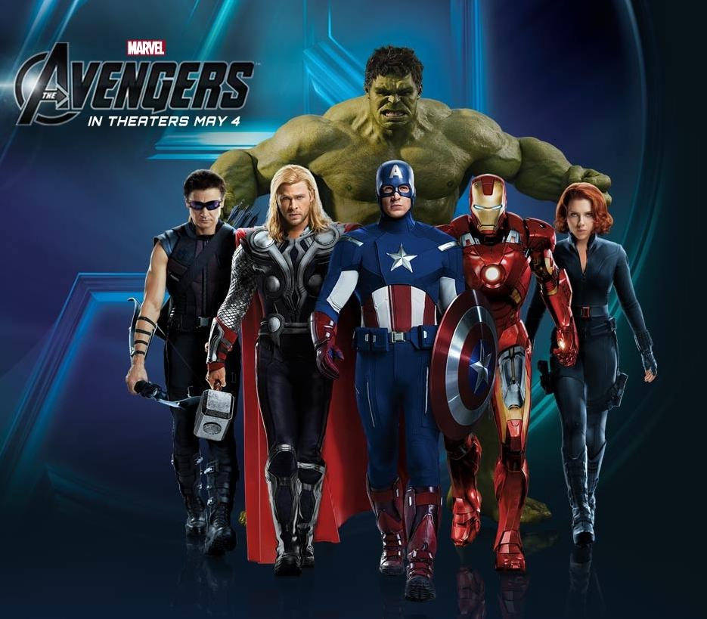
The villains Apocalypse, Ultron, and the Thanos have teamed up to take over the world. Each villain decided to attack: Apocolypse chose regions in Africa , Ultron chose Japan, and Thanos chose various countries of Southeast Asia.
Mission 1
Thanos was sent to attack three of the most populace countries of Southeast Asia. List and Name ten of the most populace Southeast Asia countries that Thanos would most likely attack.
Mission 2
The Apocalypse and the 4 horsemen attacked 5 major cities in Africa. A. List the cities and countries involved in the war. B.Then explain how you think they would attack. (4-6 sentences)
Mission 3
Ultron duplicated himself into 2 other machines and attacked Japan. A. What are 3 of the most populated cities he would choose to attack in Japan. B. Then describe the physical characteristics of the country. (3-4 sentences)

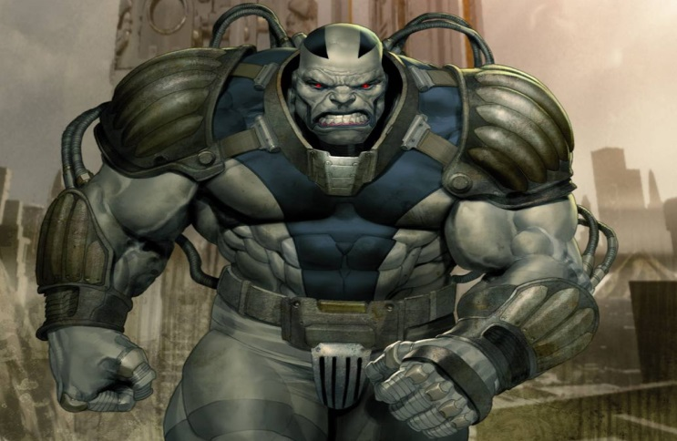
Mission 4
Break the Avengers and their allies into 3 groups to combat the three supervillains. Explain why you grouped the heroes against the villains the way you did. (2-3 sentences)
Mission 5
Explain how the climate and weather in the region may affect the fighting. (3-4 sentences)
Mission 6
Explain the damage to the environment that had resulted during the War. *This would be the destruction, lives lost, cultural/monuments destroyed and pollution that was caused. (3-6 sentences)
Mission 7
Explain who your favorite hero is and how that person did in the battle. (3/4 sentences)
Mission 8
Draw a New Avenger and explain his/her power. (Draw a Picture and color, 2-4 sentences)
Mission 9*
Create your own super villain by drawing and coloring them, and have them appear at the end of the mission with new super powers that the Avengers will fight during their next adventure.

