Geography
Key Members Allies Enemies
Spiderman X-men Ultron
Falcon Fantastic Four Apocalypse
Captain America Guardians of Galaxy Kree
Thor
Iron Man
Hawkeye
Scarlet Witch
Quicksilver
Hulk
Doctor Strange
Vision
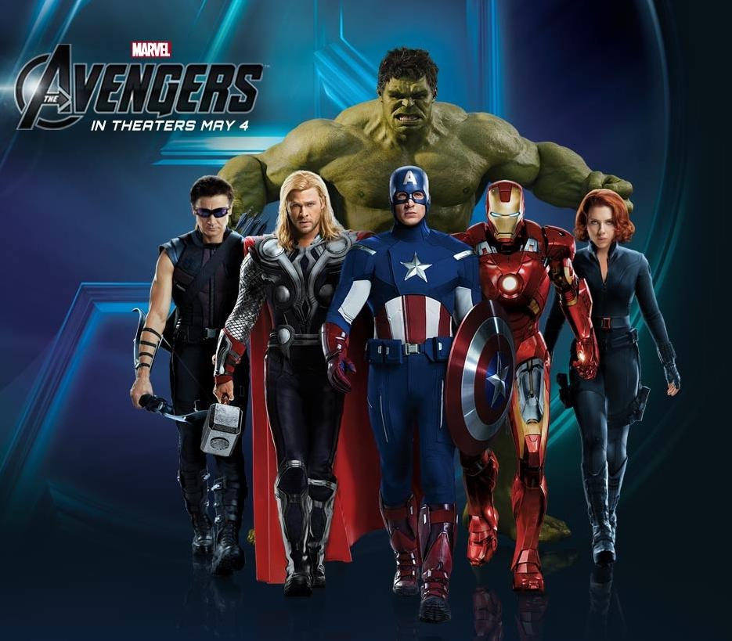
The villains Apocalypse, Ultron, and the Kree have teamed up to take over the world. Each villain decided to attack a region near Europe, making it a battleground. Apocalypse chose the countries of the United Kingdom, Ultron chose Russia, and the Kree chose various countries of Eastern/Western Europe.
Mission 1
The Kree was sent to attack ten of the most populace European countries west of Russia. List and Name ten of the most populace European countries that the Kree would most likely attack.
Mission 2
The Apocalypse and the 4 horsemen attacked 5 major cities in the United Kingdom. A.List the cities and countries involved in the war. B.Then explain how you think they would attack. (4-6 sentences)
Mission 3
Ultron duplicated himself into 2 other machines and attacked Russia. A. What are 3 of the most populated cities would he choose to attack in Russia. B. Then describe the physical characteristics of the country. (3-4 sentences)

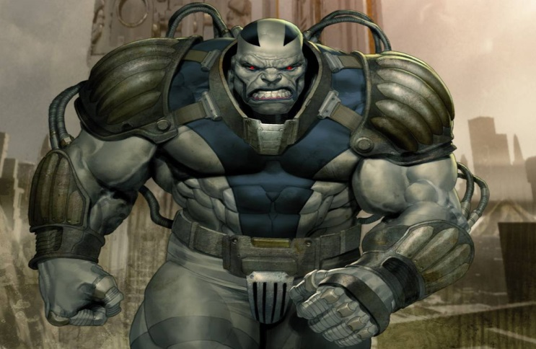
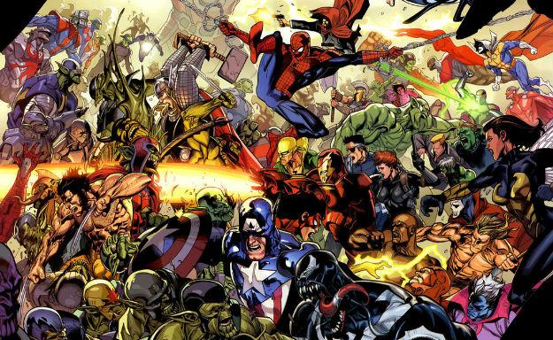
Mission 4
Break the Avengers and their allies into 3 groups to combat the three supervillains. Explain why you grouped the heroes against the villains the way you did. (2-3 sentences)
Mission 5
Explain how the climate and weather in the region may affect the fighting. (3-4 sentences)
Mission 6
Explain the Mutant/Human Interaction that had resulted during the War. *This would be the destruction, lives lost, cultural/monuments destroyed. (3-6 sentences)
Mission 7
Explain who your favorite hero is and how that person did in the battle. In your response give the relative location of the battle your hero fought in and the results. (3/4 sentences)
Mission 8
Draw a New Avenger and explain his/her power. (Draw a Picture and color, 2-4 sentences)
Mission 9*
Create your own super villain by drawing and coloring them, and have them appear at the end of the mission with new super powers that the Avengers will fight during their next adventure.

