Columbian Exchange Activity CLASS COPY CLASS COPY
Directions: Using skills you have gained during the week, answer the following short-answer questions on a separate sheet of paper.
Historical Background: In the late 1400s, European explorers found the North American continent. Native American peoples who were already living in North America had created a system of government and society that rivaled Europe's. The cultural exchange between the "New World" and the "Old World" (North America and Europe, respectively) is often called the Columbian Exchange in reference to Christopher Columbus.
Task: In well-planned sentences, identify and evaluate:
a. The reaction Native Americans had to the Europeans
b. The reaction Europeans had to the Native Americans
c. How the world changed because of the interaction between these two cultures.
Document 1: Columbus's diary
Saturday, 13 October. [1492] At daybreak great multitudes of men came to the shore, all young and of fine shapes, very handsome; their hair not curled but straight and coarse like horse-hair, and all with foreheads and heads much broader than any people I had seen; They came loaded with balls of cotton, parrots, javelins, and other things too numerous to mention; these they exchanged for whatever we chose to give them.
1. What did Columbus observe about the Natives?
2. What did the Spanish and Native Americans do together?
Document 2: Description of Aztec reaction to Cortez
Cortez was coming. Montezuma [leader of the Aztecs] had already sent wizards, magicians, and seers to cast spells that would destroy or at least deter the Spaniards from continuing towards the Capital. Their failure had re-confirmed the [Aztec] emporer's opinion that these indeed, were the gods of legend
3. What did Montezuma send to Cortez?
4. Why might the Aztecs believe the Spaniards were gods?
Document 3: Journal entry of Bartolome de Las Casas
The [the Americans] do not have weapons, nor do they know about them because when we showed them a sword, they cut themselves from grabbing the [blade].

5. How did the Native Americans show that they did not know about weapons?
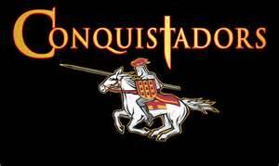
Document 4: Farming and Food calories
North America
Chief Crops | Calories  per Hectare
Maize | 7.3
Potato | 7.5
Yams (Sweet Potato) | 7.1
Cassava | 9.9

Europe
Chief Crops | Calories  per Hectare
Rice | 7.3
Wheat | 4.2
Barley | 5.1
Oats | 5.5
6. Which area had a higher calorie average? Why are calories important?
7. Of the 4 North American crops listed, which one was the most important for the Europeans?
Document 5: From Old World to New World
Pathogens | Animals | Effects
Small Pox | Horse | Native population falls
Measles | Cattle | Guns kill many Natives
8. What was one animal brought to America? Why was it important?
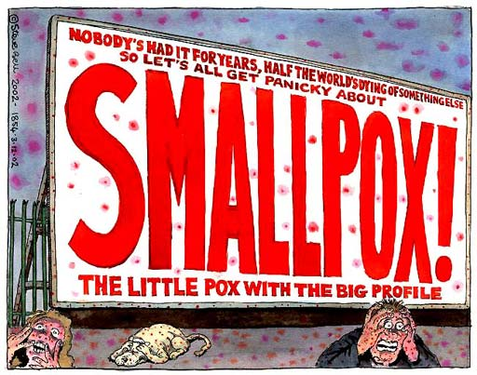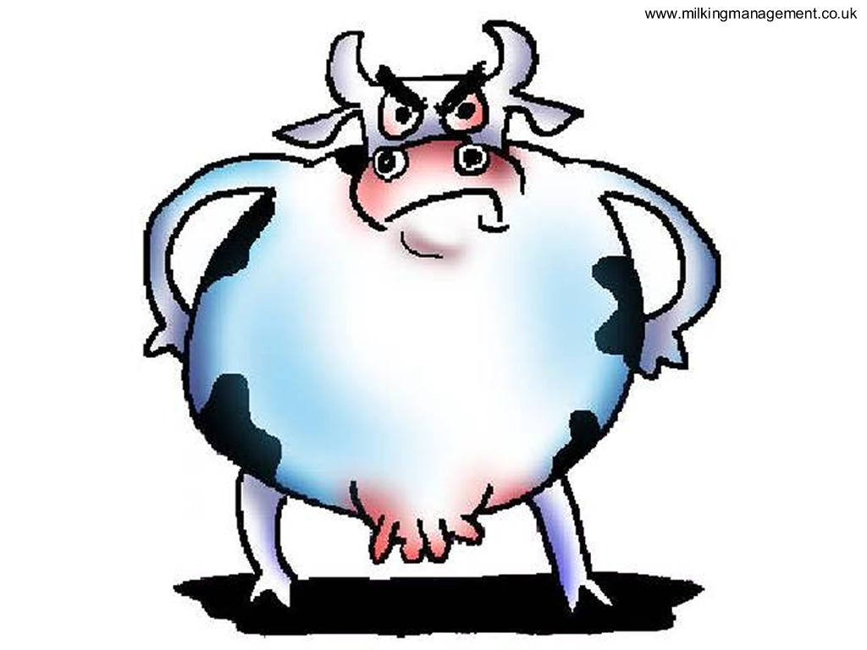
Document 6: " Loss of hand because gold quota not met"
Commissioned by B. De Las Casas
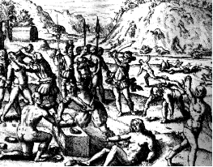
9. Based on the document, did the Spanish treat the Natives kindly?
10. According to the title of document 6, the penalty for missing the Gold quota was a loss of a hand. Why would the Spanish cut off workers hands? Was this a smart thing to do?
