**Social Studies 13.5 Week LCA Study Guide NAME:**

***European Economies***

Plot the countries on the Economics Continuum: United States, United Kingdom, Russia, Cuba, and Germany

1. 2. 3. 4. 5.

Command Market

**Economic Systems**

Command:

How does the system answer the 3 basic economic questions?

What to produce:

How to produce?

For whom to produce?

Market:

How does the system answer the 3 basic economic questions?

What to produce:

How to produce?

For whom to produce?

Traditional:

How does the system answer the 3 basic economic questions?

What to produce:

How to produce?

For whom to produce?

***Government***

***Presidential Democracy:***

**-leader:**

**-who elects leader:**

**-what makes it different from a**

**parliamentary democracy?**

**Example:**

***Parliamentary Democracy:***

**-leader:**

**-who elects leader:**

**-what makes it different from a**

**presidential democracy?**

**Example:**

**Compare and Contrast**

**Unitary Autocracy**

***What is the difference between a country’s Head of state and Head of Government?***

**How does a federal system share power differently from a confederate system?**

***Germany***

***Type of System:***

***Head of State:***

***Head of Government:***

***Russia***

***Type of System:***

***Head of State:***

***Head of Government:***

***United Kingdom***

***Type of System:***

***Head of State:***

***Head of Government:***

***Who is in power and how can citizens participate?***

***Autocracy Oligarchy Democracy***

**What is the main purpose of the European Union and what type of government system does it closely resemble?**

***Factors of Economic Growth***

**Trade Barriers**

**Tariff Quota Embargo**

**A tax on imported a limit placed on the cutting off or blocking all trade**

**Goods number of imported goods with a country**

**Ex: Tariffs on sugar make Oreos more $$ Ex: US puts a limit on imported tomatoes Ex: US and Cuba**

**Factors of Economic Growth**

**B Capital Goods A. A person who takes the risk to start a business**

**D Human Capital B. A tool or equipment used to produce other goods**

**A Entrepreneur C. “Gifts of Nature” that come naturally from the earth**

**E Factors of Production D. Skills and services that people invest into to contribute to the workforce**

**C Natural Resources E. Land, capital, labor, and entrepreneurship**

**Gross Domestic Product (GDP)**

**How does GDP resemble a calculator? Give a definition and make a connection.**

**It’s like a big calculator that keeps track of all of the $ spent in a country in a year**

**Directions: Fill in the blank to show a cause/effect relationship between factors of economic growth and GDP**

1. **If there are more entrepreneurs then THERE ARE MORE JOBS AVAILABLE AND THE GDP WILL GO UP BECAUSE PEOPLE ARE MAKING MORE MONEY**

1. **If a country has fertile land and natural resources then THEY CAN MAKE MORE MONEY BY EXPORTING THE GOODS TO OTHER COUNTRIES**

1. **If a county invests in education then STANDARD OF LIVING AND LITERACY RATES INCREASE BECAUSE PEOPLE CAN GO TO COLLEGE AND GET JOBS THAT MAKE MORE MONEY**
2. **If a farmer purchases capital goods such AS TRACTORS THEN THEY WILL BE ABLE TO WORK QUICKER AND YIELD MORE CROPS AND THEN THE GDP WILL GO UP**

1. **If Russia has no access to ports because of frozen water then THE GDP WILL DECREASE BECAUSE THEY CANNOT EXPORT GOODS UNLESS THEY RELY MORE HEAVILY ON DOMESTIC NATURAL RESOURCES AND MANUFACTURING.**

|  |  |  |  |
| --- | --- | --- | --- |
| **Country** | Literacy Rate | GDP (2008) | GDP per person |
| **United States** | 99% | $2.3trillion | $37,400 |
| **Germany** | 99% | $2.9trillion | $34,800 |
| **Russia** | 99% | $2.2trillion | $15,800 |
| **Spain** | 98% | $368billion | $14,000 |
| **Brazil** | 91% | $1.6trillion | $14,400 |
| **Kenya** | 89% | $200billion | $10,300 |

1. Do all countries with a high literacy rate have a high GPD?

1. What is the definition of GDP per capita?
2. Which country has the lowest GDP?
3. What are other ways a country can increase its GDP besides improving literacy?
4. How do standard of living and literacy rate relate to one another?

**European Union**

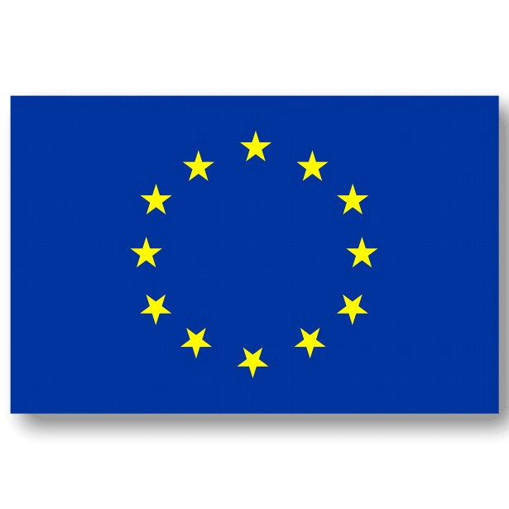 European Union Flag **What is the main purpose of the European Union?**

**What government system does the EU closely resemble?**

**How does the EU flag represent this type of government system?**

**What is one effect of immigration in the EU?**