JA Biz Town

- Click on the JA BizTown Simulation Link below and create your account

- JA BizTown Virtual Simulation URL – https://adventures.ja.org/biztown/?areaId=100301

- Students Login Information – Please share the URL Link with each student, once the students open the link they will be asked to create an account.
  - Email – The system doesn’t require an active email; therefore, for the email line we would like your students to use the following name convention - firstname.lastname@fulton.com
  - School – Students just need to add their school as follow – Renaissance MS
  - Teacher – Your Teacher’s name

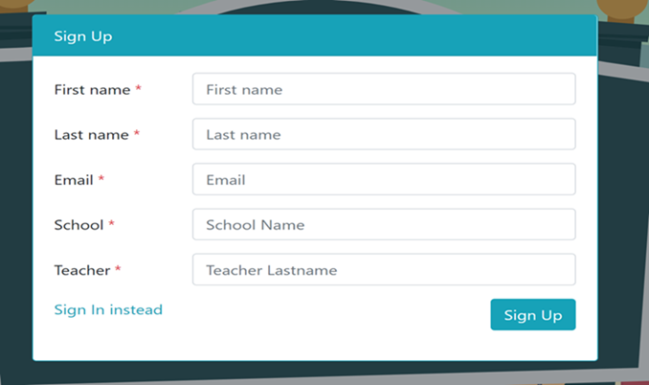
- Sign up
After sign up start your virtual Simulation. The Simulation avatar will walk you through the 5 different job titles which will . Do one job at a time. After each job simulation you will earn a certificate for each job you complete. Try to do as many as you can before Friday. Then email the job certificate to your teacher’s email. Your emailed job certificate will be your grade!
My email is Calloway@fultonschools.org

