Latin America and the Caribbean Map Name:
Instructions: Label the map on this page with the following
countries, bodies of water, and landforms.

Major Physical Features
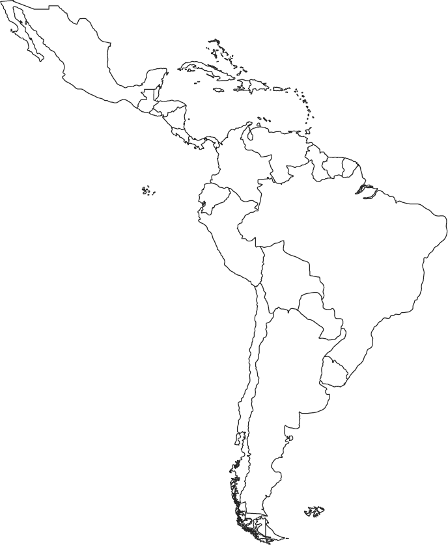
Pacific Ocean
Caribbean Sea
Gulf of Mexico
Amazon River
Andes Mountains
Sierra Madre Mountains
Atacama Desert
Panama Canal
Amazon Rainforest

Countries
Cuba
Mexico
Panama
Colombia
Venezuela
Brazil
Bolivia
Haiti

