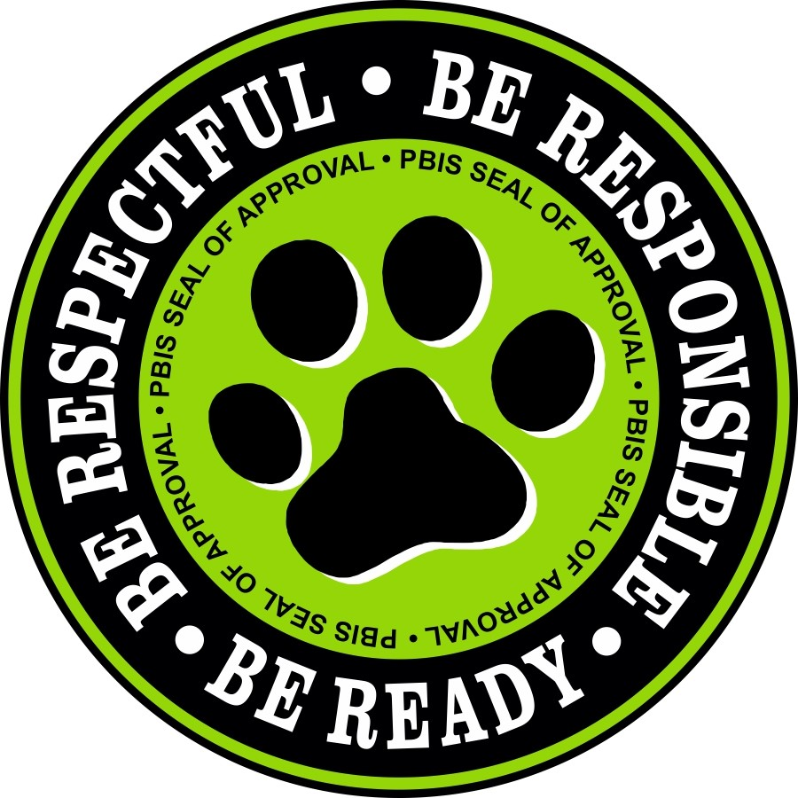

Renaissance Middle School
Virtual PBIS Tier 1 and Tier 2 Lesson Plan

TIME ALLOTTED: 15-20 minutes
MATERIALS: 1 Adults – Teaching Virtual Poster of Classroom Expectations –
WILDCAT CHARACTER
WE ARE RESPECTFUL | WE ARE RESPONSIBLE | WE ARE READY
- Cameras on unless otherwise instructed  - Raise Hand to be acknowledged by instructor before speaking  - Respect other cultures, opinions and viewpoints | 1. Attend Class Everyday  2. Attentive, Employ active listening  3. Participate Actively | 1. Classroom Materials  2. Be on Time to Class  3. Ask for Help when needed

TEACH A. Overview of the lesson: “Today we are going to talk about how ‘we are respectful, responsible, and ready while we are in the Universal Remote Learning Classroom”.
B. Guided Discovery: “Could someone tell us what we are going to learn and practice today?”
C. Definition of WILDCAT CHARACTER when in the classroom: See above matrix for expectations.
1. Show the Teaching Poster of Expectations with pictures and walk through the expectations.
2. Discuss the detail of the expectations with students.

MODEL A. Demonstrate examples of not following expectations.
1. Respectful – Show an example of not having your camera on (i.e., screen showing only name of student), raising hand in virtual world(show button in Teams). Talk with students about how else a person might not be following the Respectful expectation in the classroom when addressing others cultures, opinion and viewpoints.
2. Responsible - Show example of being quiet (i.e., sitting in desk, completing assignments, waiting for instructions). Talk with students about how else a person might not be following the Responsible expectation in the classroom.
3. Ready - Show example of not having materials for class. Talk with students about how else a person might not be following the Ready expectation in the classroom.

B. Choose a couple of students to “show” examples of following the expectations.
1. Respectful – Show an example respecting others cultures, opinions and viewpoints (i.e., facial expressions, gestures) Complete the No place for Hate Virtual Resolution of Respect, please provide link to students to sign Resolution, https://tinyurl.com/y2tgy4yr

2. Responsible – Show an example being.
3. Ready – Show an example of having classroom materials (i.e., Pens, paper, books, and tablet)
C. Discussion. “Tell me what “Respectful, Responsible, and Ready look, feel, or sound like when in the Universal Remote Learning Classroom.”

PRACTICE A. Students practice being quiet, keeping Mic on Mute unless instructed to speak, raising hand to be acknowledged by instructor before speaking and attentive all of the way through, with an adult monitoring.
B. Debrief with students any questions. “Are there any questions you have about being respectful, responsible, and ready behavior while in the Universal Remote Learning Classroom”?

AREA: BODY BASICS “Temperature and Mood Check” TIME ALLOTTED: 15-20 minutes
MATERIALS: 2-3 Adults – Teaching Poster of Body Basics “Temperature and Mood Check” – “Temperature and Mood Check” Poster
WILDCAT CHARACTER
WE ARE RESPECTFUL | WE ARE RESPONSIBLE | WE ARE READY
1. Be Honest  2. Respect others viewpoint | 1. Be present and avoid multitasking  2. Ask for Help when needed | 1. To Discuss (Private Chat if needed)

TEACH A. Overview of the lesson: “Today we are going to talk about how ‘we are respectful, responsible, and ready when given the nonverbal signal of an thumbs up and/or the verbal signal ‘Temperature and Mood Check”
B. Guided Discovery: “Could someone tell us what we are going to learn and practice today?”
C. Definition of WILDCAT CHARACTER for the nonverbal signal of a Thumbs up or Thumbs down and/or the verbal signal of ‘Temperature and Mood Check”
See above matrix for expectations.
1. Show the Teaching Poster of Expectations with pictures and walk through the expectations.
2. Discuss the detail of the expectations with students.

MODEL A. Demonstrate examples of not following expectations.
- Respectful – Show example of not Respecting others view (i.e., laughing out loud in classroom about classmates statement without being addressed by teacher, making faces), Talk with students about how else a person might not be following the Respectful expectation when given the nonverbal signal of a Thumbs up or Thumbs down and/or the verbal signal of ‘Temperature and Mood Check”

- Responsible - Show example of not be present and multitasking (i.e., eyes not on camera, completing other task, camera off), Talk with students about how else a person might not be following the Responsible expectation when given the nonverbal signal of a Thumbs up or Thumbs down and/or the verbal signal of ‘Temperature and Mood Check”

3. Ready - Show example of not discussing properly (i.e., Mic not on Mute, when speaking not using appropriate language , tone and facial expressions when responding. Talk with students about how else a person might not be following the Ready expectation when given the nonverbal signal of a Thumbs up or Thumbs down and/or the verbal signal of ‘Temperature and Mood Check”

B. Choose a couple of students to “show” examples of following the expectations.
1. Respectful – Show an example proper tone when being addressed or answer questions in the virtual classroom (i.e., answer a question),
2. Responsible – Show an example of raising hand in virtual classroom (i.e., use icon in Teams).
3. Ready – Show an example of having materials (i.e., books, pencils, pens, assignments).
C. Discussion. “Tell me what “Respectful, Responsible, and Ready look, feel, or sound like when given the nonverbal signal of a Thumbs up or Thumbs down and/or the verbal signal of ‘Temperature and Mood Check”

PRACTICE A. Students avoid multitasking and follow the expectations all of the way through, with an adult monitoring.
B. Debrief with students any questions. “Are there any questions you have about being respectful, responsible, and ready behavior when given the nonverbal signal of a Thumbs up or Thumbs down and/or the verbal signal of ‘Temperature and Mood Check”

Temperature and Mood Check Poster

Goal: Ask for Help when you need it!
Directions: You the teacher will ask the students “How are your Temperatures and Moods today, the students will type the color they feel for their temperature first, and a use the “thumbs up” symbol for a good mood or “thumbs down” for a bad mood second, all in the same chat.
If a student is in a Bad Mood or temperature is other than Yellow, Please email the PBIS and Student Culture Coach the students name so that he or she may have a Restorative session with the student to find out if there are any needs (familial problems, professional school counseling services, academics,behavioral( PBIS Tier Adjustment( Tier 2, Tier 3 etc.). Take at least 3 minutes to discuss some of the good moods your students are feeling, build a rapport. Private Chat Bad Mood students, that the PBIS Coach will be contacting them to discuss their mood and/needs if any. Share the poster below with students.
Mood Check

Good Mood |  | Bad Mood
Temperature Check
Color | Purpose |  | Emotion
Yellow | To leave you with a feeling of great pleasure and happiness |  | Joy
Red | To leave you with a strong feeling of annoyance, displeasure, or hostility |  | Anger
Blue | To leave you with a feeling of grief or unhappiness |  | Sadness
Purple | To leave you with an unpleasant emotion caused by the belief that someone or something is dangerous, likely to cause pain, or a threat |  | Fear

