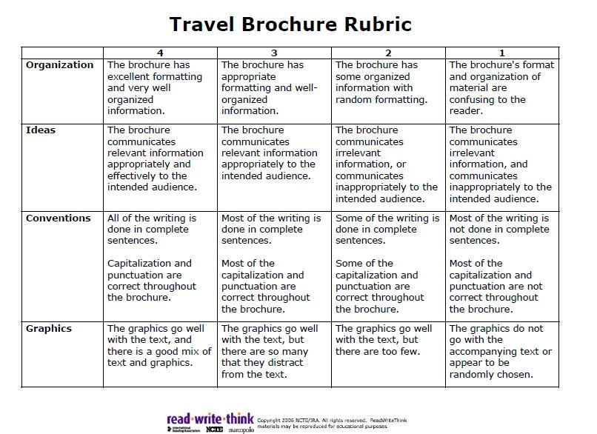
Things to Include in a Travel Brochure

• Brief summary of the setting, with highlights of important places
• Location, including a map
• Geography
• Major cities, Well-known places
• Historic Sites and Landmarks
• Recreation and Outdoor Activities—parks, sports, water
• Entertainment
• Climate and overall weather conditions
• Transportation
• Arts and Culture, including museums, theaters, places to visit
• Languages and Local Dialect
• Food that the area is known for
• Pictures/Graphics
• Additional Information

