Unit 5 Post Test Study Guide
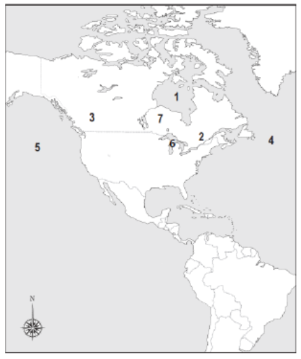

- Which physical feature is located at number 4?

- Which physical feature is located at number 1?

- Which physical feature is highlighted on the map?

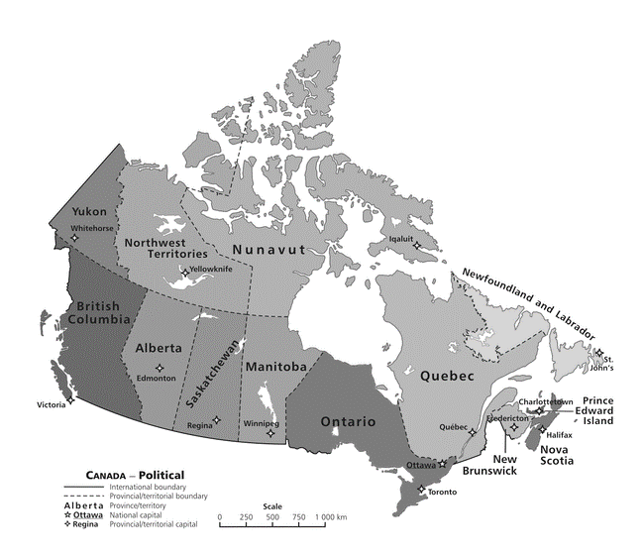

- Which Canadian territory borders Alaska & is located on the western coast of Canada?
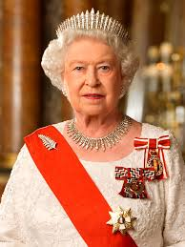
- Write three examples of Canada’s natural resources

- What is an environmental concern for the Great Lakes?

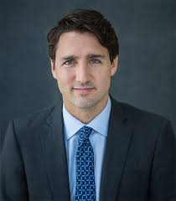
- What type of government does Canada have?

- Who is the Head of Government?

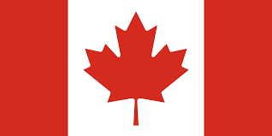
- Who represents Queen Elizabeth II in Canada?

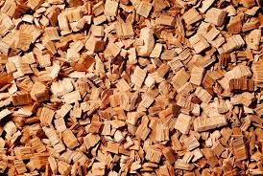
- What are the three economic questions?

- What type of economy does Canada have?

- What is specialization?

- What is NAFTA?

- Which three countries created a free trade zone because of NAFTA?

- Why did the people of Quebec want to gain independence from Canada?

